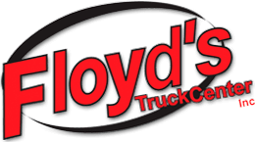
Floyd’s Truck Center, Inc.
Brian H. Greif Memorial Scholarship
For those interested in pursuing a career as a Diesel Technician, the Brian H. Greif Memorial Scholarship will award up to Three $5,000 Scholarships to students who are interested in attending one of the following colleges:
- WyoTech / Laramie, Wyoming
- Western Dakota Tech/ Rapid City, South Dakota
- Northeastern Junior College / Sterling, Colorado
- Laramie County Community College / Cheyenne, Wyoming
- Western Wyoming Community College / Rock Springs, Wyoming
- Casper Community College / Casper, Wyoming
- Gillette Community College / Gillette, Wyoming
- Lake Area Technical Institute / Watertown, South Dakota

Up to Three $5,000 Floyd’s Truck Center, Inc. scholarships will be awarded, payable for two year or equivalent study, with $1250 awarded per semester (based on four semesters), or $5000 based on clock/credit hour equivalent in a 9-month program of study. Up to three winners and one alternate will be selected by a donor-advised committee of Floyd’s Truck Center, Inc., with final approval of the OTCF Scholarship Committee.
Eligibility, Application and Selection Process:
- Available to graduates and graduating seniors planning to attend college the following fall.
- Full-time Enrollment into a diesel technician program will be required.
- Scholarship recipient must maintain a grade point average required to remain in good standing in the school in which they are enrolled.
- Application forms are available from the Oregon Trail Community Foundation website (www.otcf.org), at Floyd’s Truck Center or from school counselors. For more information call (308) 635-3393. High school applicants are required to attach a copy of their official ACT/SAT scores and their current high school transcript.
- The scholarship will be rescinded and awarded to a designated alternate if the recipient does not enroll as a full-time student for the first semester for which the scholarship is awarded.
Applicants must provide a short application relating to goals, training path or plan, future employment interests and 3 letters of recommendation.
Applications must be submitted to the Oregon Trail Community Foundation by April 1st. All applications will be reviewed by the OTCF Scholarship Committee, with the finalists forwarded on to the Floyd’s Truck Center, Inc. Scholarship Committee.

Together, we will keep the legacy of Brian alive with integrity and commitment to our customers, fellow employees, and our trade.

…………………………………………………………………………………………………………………………………………………………………

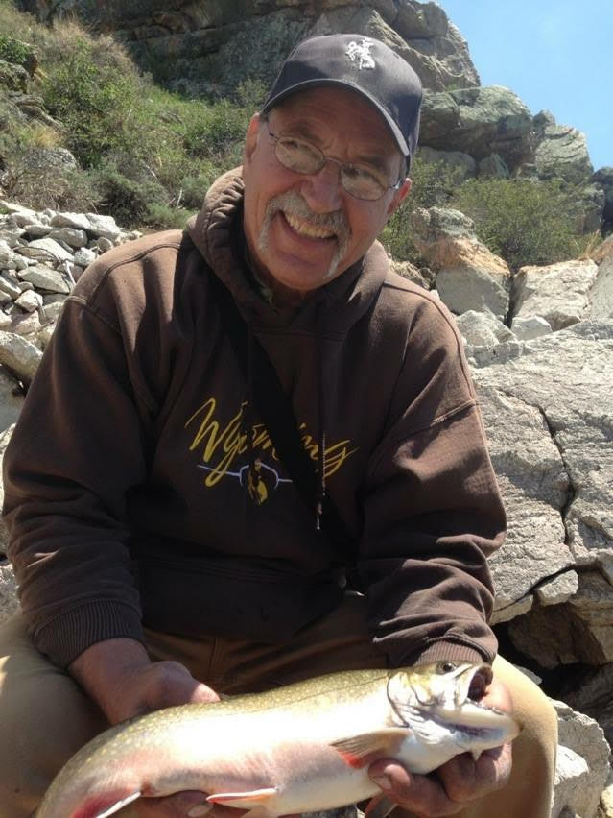
Brian H. Greif
Isaiah 55:6-13

A lifelong expert and professional diesel technician, Brian Greif was a mentor to many young aspiring diesel technicians during his 30 plus year career. Throughout those years, Brian built a strong customer base, with many customers choosing him personally to repair their equipment and entrusting him to keep their trucks on the road.
Floyd’s Truck Center, Inc. had the distinct privilege of having Brian in our organization for 22 years as a lead technician, leader, mentor, Service Manager and most importantly, a member of our family.
Brian made us all a little bit better, both on a professional level and personal level. We are excited about the opportunity to pay it forward and ensure that his legacy in the diesel world lives on, inspiring young technicians to be their very best.

