Class of 1988 Memorial Scholarship
Linda LaFave-Sandau

Members of the Sully Buttes High School Class of 1988, who all share the common bond of friendship, love and cherished memories of our dear friend, established this scholarship in her honor.

“I love you all very much and look forward to our reunion in Heaven. Do what you need to do to make that happen, okay?”
--Linda

Linda LaFave-Sandau
1970 – 2004

Applications will be considered by the following terms of importance:

- Applicants must be graduating seniors of ABO School District (Sully Buttes High School) who plan to attend an accredited college or university.
- Applicants must demonstrate Christian Faith, desire and ability to accomplish their goals.
- Successful candidates must be involved in school and community activities.
- Preference may be given to students planning to pursue a career in Music Education.

Application Deadline: 3/01/19

To be eligible for Consideration, you must submit:

Scholarship Application. You will attach separate sheets of paper to respond to Section III, Community Activities; Section IV, Work Experience; and Section V, an Essay.
- Recommendation Form (1). You will submit one recommendation from a high school teacher or administrator who is not related to you. Family members or selection panel members may not serve as references.
Please Note:

- Your application will be duplicated for a selection committee. Photocopy and write on only one side of each sheet of paper.
- Any transcript, certification, or recommendation submitted is subject to verification.
- If you have questions about this application, please call the scholarship administrator at (253)961-6233 or via email to MarthasNightmare@comcast.net.
- Complete your application and submit all required forms--including any required transcript, certification, or recommendation--in one package.
- $500 will be awarded to the student selected.

Your submission must be postmarked no later than March 1, 2019. Send to:

Class of 1988 Memorial Scholarship Committee

c/o Dawn Lamb-Wagner
4419 Towhee Dr NW
Gig Harbor, WA 98332

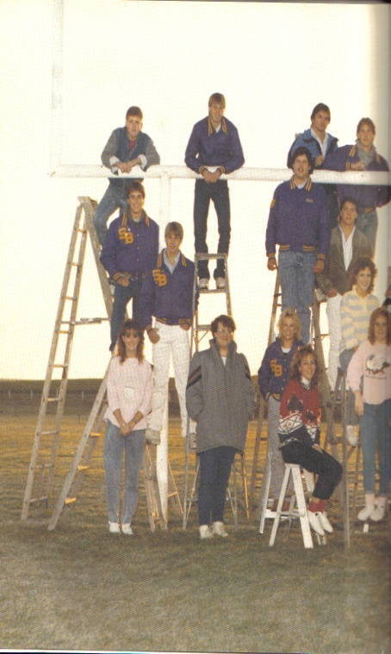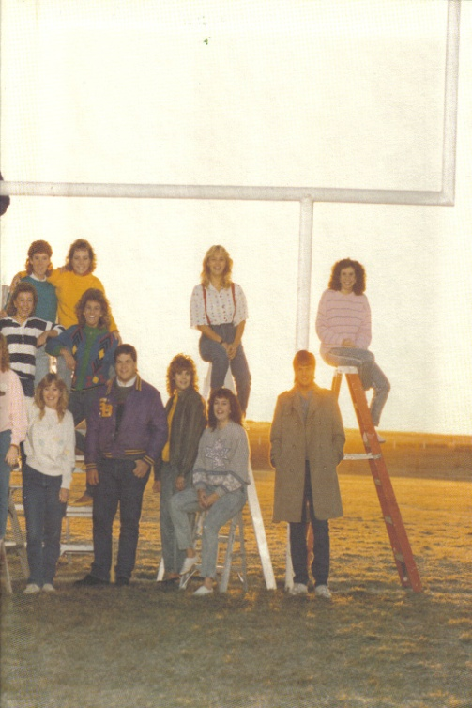

Class of 1988 Memorial Scholarship

Application Form

Please type or print responses in black ink and complete all sections.

I. STUDENT INFORMATION

Student’s Name:
_____________________________________________________________Last, First, Middle

Permanent Address:
_____________________________________________________________Street, City, State, Zip

Phone Number: ________________________________________________

Parent/Guardian Name:
_____________________________________________________________Last, First

Name of high school _______________________Graduation date________

Name of college you plan to attend:

_____________________________________________________________

Please address the following using additional sheets of paper where applicable. (Use one side of paper only.)

II. LETTER OF RECOMMENDATION (Use form provided.)
Applicants are required to submit one recommendation from a high school teacher or administrator. Under no circumstances may family or selection panel members serve as references.

III. COMMUNITY ACTIVITIES
List the community activities you have participated in during your high school years, any offices held and/or awards received, and year(s) of involvement.

IV. WORK EXPERIENCE
Describe paid work experience and/or volunteer work you have had in the past four years. List position, employer, and dates of employment.

V. ESSAY
Write an essay of no more than 500 words describing your goals for the future and how your high school experiences helped shape the person you are/will become.

VI. SPECIAL CIRCUMSTANCES
Indicate any special personal or family circumstances you would like the selection committee to be aware of.

CERTIFICATION
I certify that all information on this form is true and complete to the best of my knowledge.

_____________________________ _____________________________
Applicant’s signature Applicant’s name (print)

Dated this _____ day of _______________, 2019.

Submit this application and all required forms (postmarked by March 1, 2019) to:
Class of 1988 Memorial Scholarship Committee

c/o Dawn Lamb-Wagner
4419 Towhee Dr NW
Gig Harbor, WA 98332

Class of 1988 Memorial Scholarship

Recommendation Form

Applicant’s Name: _____________________________________________

This student is applying for a scholarship and has asked for your recommendation as part of the
Application process. All recommendations are kept strictly confidential. Under no circumstances may family or selection panel members serve as references. Doing so will result in disqualification for this applicant.
- Please do not write or type on backside of this paper.
- Attach additional sheets of paper if necessary.
- When finished, place form in a sealed envelope and write your name across the seal.
- Return to applicant as soon as possible. Applications must be postmarked by March 1, 2019.

Please type or use black ink.

1. How long have you known the applicant?

More than 10 years 5-10 years 3-5 years 1-3 years

2. How have you been acquainted with this applicant?

3. What qualities make this applicant a good candidate for this scholarship?

4. Additional comments. Please add any information you feel might assist the selection committee in making a scholarship award. [Attach additional sheet(s) if necessary.]

________________________________ ___________________________________
Signature Street Address

________________________________ ___________________________________
Print or type name City, State, Zip Code

________________________________ ___________________________________
Title (if school official) Telephone

