CRAIG M. HILTON
MEMORIAL SCHOLARSHIP BIOGRAPHY

Craig Hilton was born in Pierre and grew up in Onida, graduating from Onida High School in 1962. Craig participated in a variety of extra curricular activities in high school, including band, where he played percussion, all-state chorus, and sports. Craig started as a guard on the basketball team, played quarterback on the football team and served as class president, but he was remembered as an “outstanding track athlete” by his teammates. Onida won the state track meet in 1961 and 1962 during which Craig ran the open 100 and 220 as well as 440 and 880 relays. At state in 1961, Craig won the open 100 and was part of the 440 and 880 relays which won state. At state in 1962 Craig won the 220 and was 4th in the 100 and also ran on relays teams that placed at state. Craig was remembered for his contribution to athletics when inducted into the Sully Buttes Athletic Hall of Fame in 2008.
Craig was also a good student. He would graduate and go on to attend college at Northern and earn a business degree. Here, Craig continued in athletics, playing college basketball and running on a conference championship track team.
After years of owning his own store in Redwood Falls, MN, working for the Chamber of Commerce and serving as President of the Jaycee’s, Craig moved back to Pierre to work for Bank West where he retired 20 years later as Senior Vice-President in charge of credit for the Bank West system, overseeing all of the bank locations.
Craig was taught tenacity and a good work ethic at a young age by watching his mother, Virginia, care for him on her own after his dad, Clifford Hilton, died when he was just 11. His mother would go on to remarry, but their mother/son relationship would always be close.
Later in his career, Craig spent much of his time motivating and educating Bank West staff using life lessons he’d learned. He enjoyed this role and celebrated the successes of his family, staff, neighbors and friends. He would be proud to know the student receiving this scholarship would use the money to help him/her define and work toward their own personal success at college, knowing that growing up in Onida is a great start!
Craig with sons,
Tim (left) and Chad (right).

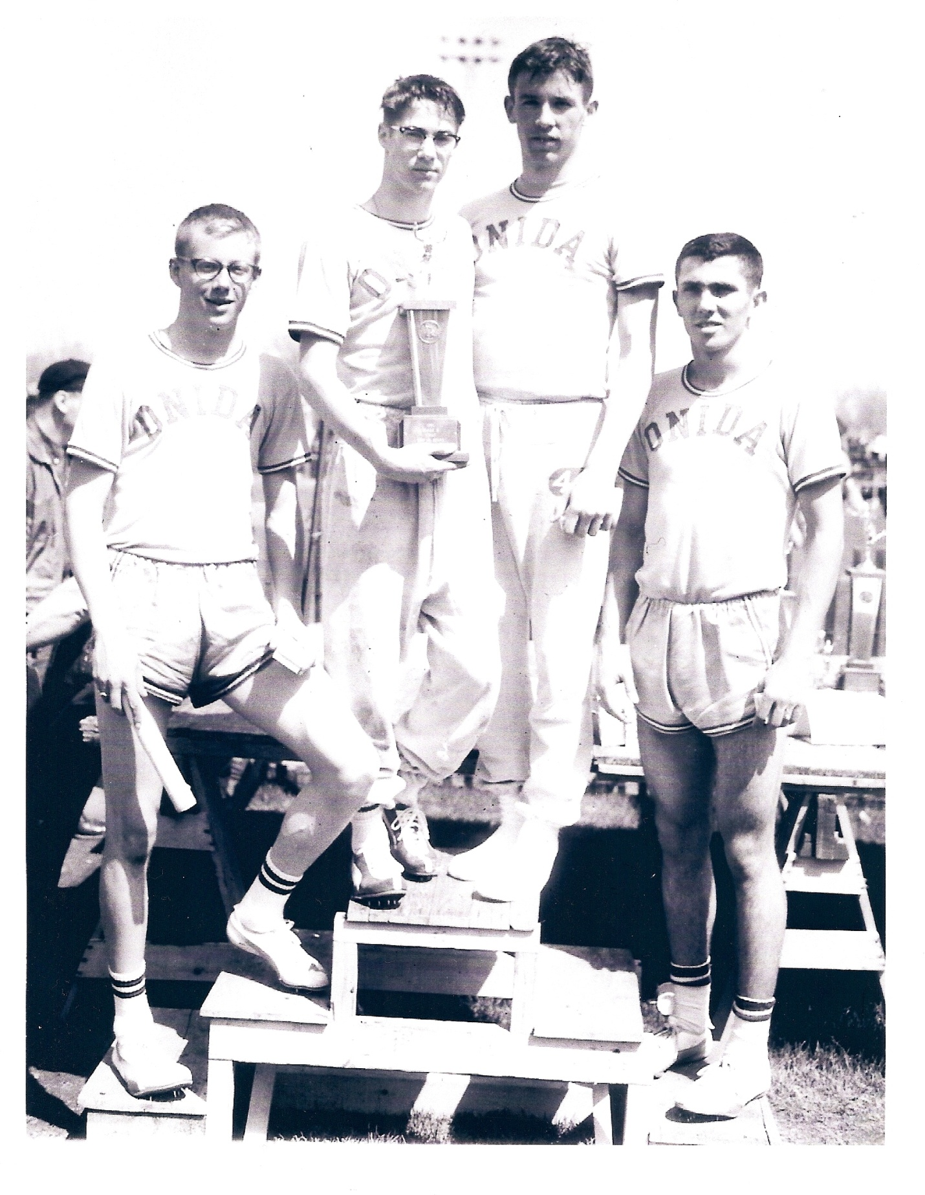
Craig (far left) -
H.S. Relay Team

CRAIG M. HILTON MEMORIAL SCHOLARSHIP APPLICATION

The recipient will meet the following criteria:
1. Be a senior at Sully Buttes High School
2. Participated in track in high school
3. Maintain a GPA of 2.8 or better
4. Attending an accredited post-secondary institution in the fall

In preparing this application, all blanks must be typed. Graduating high school seniors who enroll in a post-secondary educational institution are eligible to apply for this scholarship.

- Name of applicant in full:

_____________________________________________________________________
Last Name First Name Middle Name

- Address in full:

_____________________________________________________________________
Street or Box Number City State, Zip

- Parents or legal guardian name in full:

_____________________________________________________________________

Father/Mother/Legal Guardian

- Parents or legal guardian address in full:

_____________________________________________________________________
Street or Box Number City State, Zip

5. ACT Score: __________ Grade Point Average__________ Class Rank:__________

- Scholastic Achievements:
- Organizations:

- Honors and Awards:

- Offices and Positions:

- Extra-curricular (school-related):
- Activities:

- Honors and Awards:

- Positions Held:

- Non-school related activities (i.e. scouting, etc):

- Course of study applicant intends to pursue:

- Please write a brief autobiography describing your experiences to date, indicating
your hopes and plans for the future. (Attach to Application)

- An official copy of your high school transcript is required. A copy of the student’s
ACT scores is also required, provided the student completed this test.

- Name of college or post-secondary school and address at which the applicant has
been accepted.

- For your information, the scholarship award check will be deposited with the post-
high school educational institution upon notification that the scholarship recipient has enrolled. Pursuant to such notification, the check will then be sent to the appropriate educational institution. This scholarship award will not be contrary to principals of law and order and morality. The selection committee shall consist of: K-12 instructors, superintendent, secondary principal, and school counselor.

- ONE scholarship will be awarded in the amount of $500 and will be sent directly to the post-secondary institution in August and December.

- Deadline date for submitting this application is April 13, 2016. Return applications to
Mrs. Sweeter. She will attach your high school transcript to your application. PLEASE NO STAPLES.

